Multiple Accelerometer (MPU6050) data logging + NRF24 + PC

Trace Stewart, Guillermo Galvez

**Goal:**

The Goal of our project was to use 2 to 3 accelerometers and send the accelerometer and gyro data from one AVR to another with the use of NRF24 chips. We would then display the values received onto a terminal. To do this, we used I2C and SPI techniques to get, read, and send the data.

**Deliverables:**

This project was to implement multiple MPU6050 devices along with AVR’s and NRF24 chips to send data and receive data wirelessly.

# Literature survey[1]

# Components

## Atmega328p

The ATmega328p is an 8 bit microcontroller by Atmel. This microcontroller works by programming in either C or assembly. The code written will allow the users to determine what pins they want to set as input and output. This microcontroller consists of 32 general purpose registers. The ATmega328p consists of 6 PWMs, 3 timer/counters, up to 1kB EEPROM, 2kB SDRAM, I2C interface, SPI interface, 10-bit ADCs, and an 8MHz clock. The ATmega328p, however, is limited in the amount of pins can be used as input and output. Also, only one 16 bit timer exists on the chip and only one USART module is included.

## MPU6050

The MPU6050 is an inertial motion unit (IMU) that has 6 degrees of freedom. Simply put, this means the device can measure 6 different motions: 3-axis gyroscope and 3-axis accelerometer. The device also has a temperature sensor, but is not used in this implementation. The MPU6050 is interfaced via I2C communication. With the use of the DMP (Digital Motion Processor) integrated on the MPU6050, users can also determine angles or implement methods of their own. The MPU6050 does not include a magnetometer like other IMUs, which limits its ability for more precise Euler angles calculations and determination of orientation.

## NRF24l01+

The NRF24L01+ is a highly integrated, ultra low power (ULP) 2Mbps RF transceiver IC for the 2.4GHz ISM (Industrial, Scientific and Medical) band. With peak RX/TX currents lower than 14mA. The NRF24L01+ integrates a complete 2.4GHz RF transceiver, RF synthesizer, and baseband logic including the Enhanced ShockBurst hardware protocol accelerator supporting a high-speed SPI interface for the application controller.

# Schematics MPU-6050 ad0

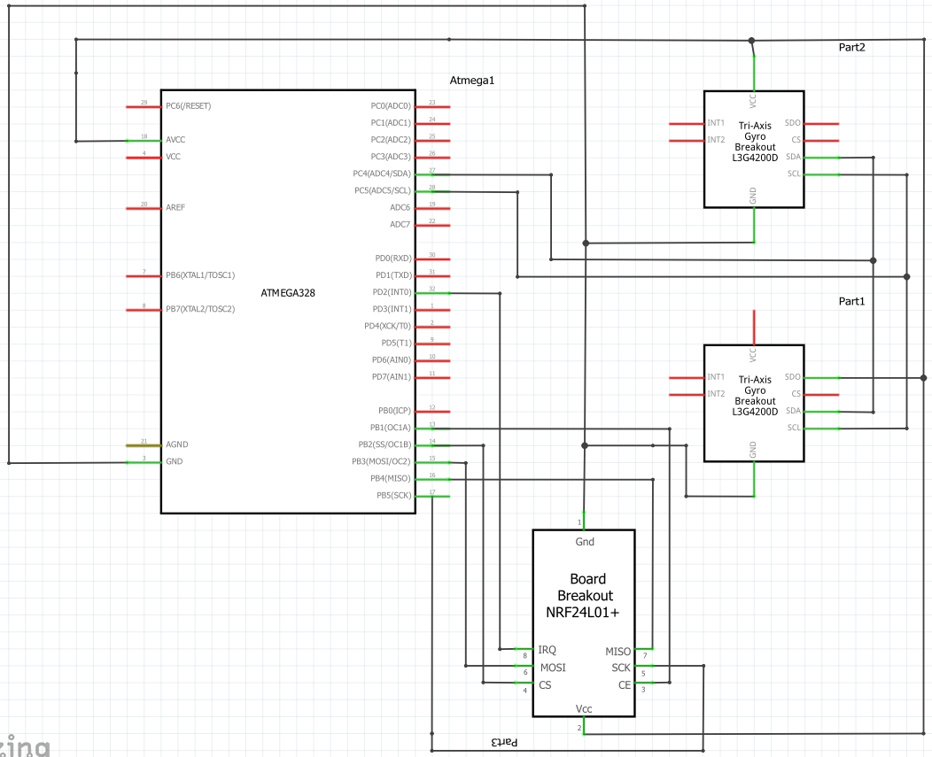

**Figure 1 The transmitter portion of the project**

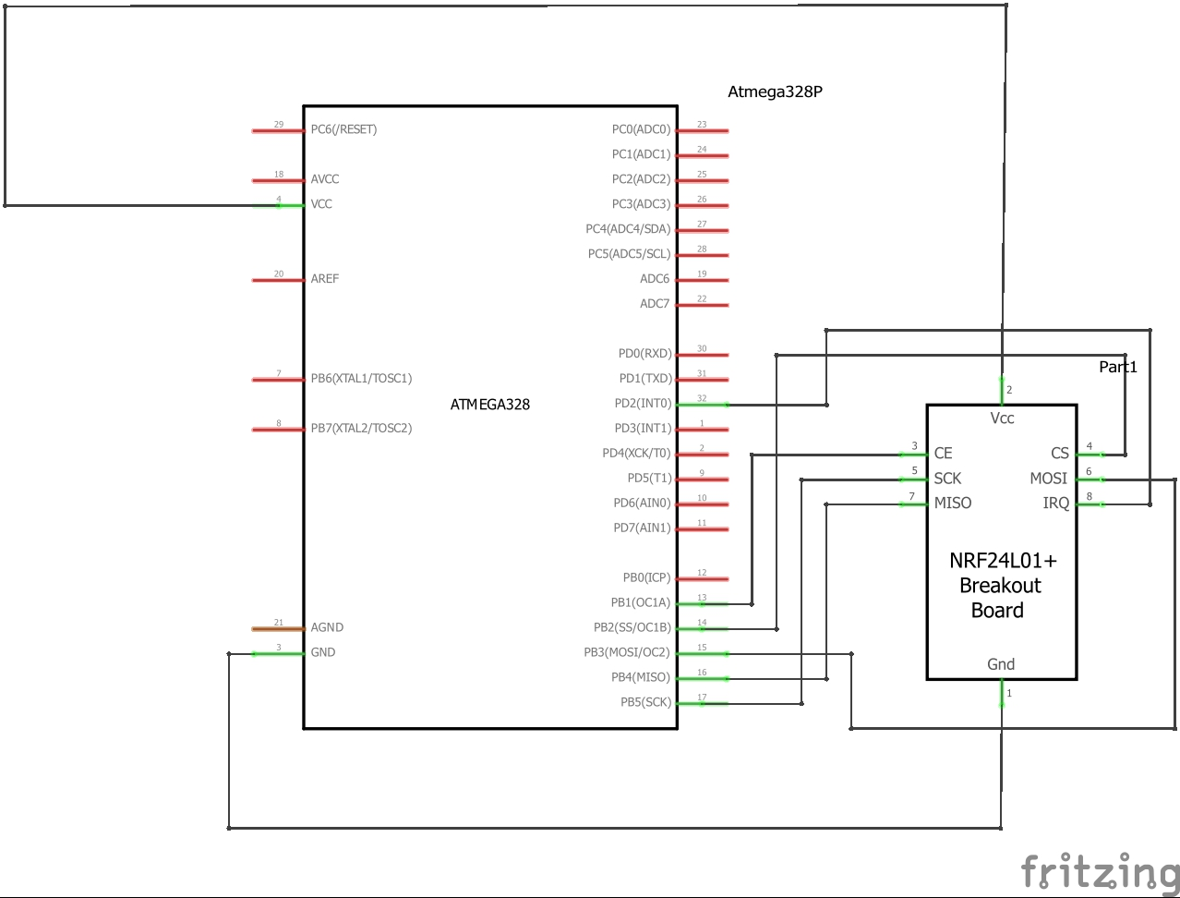

**Figure 2 The Receiver portion of the project**

# Implementation

For our implementation, we interfaced 2 MPU6050’s via I2C with the Atmega328p. The Atmega328p would send data to the MPU and the MPU would send the accelerometer and gyro back to the AVR which would then be transmitted through the NRF24 via SPI. The receiving NRF24 would receive the data from the transmitted NRF24, which would then communicate with the AVR via SPI. The AVR would then display the values that were collected from the MPU6050’s onto a terminal like shown below in the pictures.

Kalman filters are discrete, recursive filters that allow the use of mathematical models to gain an estimate of a system state, despite the presence of significant error in real time measurements. By using a Kalman filter, noisy accelerometer, gyro, and magnetometer data can be combined to obtain an accurate representation of orientation and position.

# Code

**TRANSMITTER CODE:**

#define *F_CPU* 8000000UL

#include <avr/io.h>

#include <util/twi.h>

#include <util/delay.h>

#include <stdlib.h>

#include <math.h>

#include "i2c_control.h"

#include "MPU6050.h"

#include "usart.h"

#include "ESP8266.h"

#include <avr/interrupt.h>

#include <stdbool.h>

#include <string.h>

#include "nrf24l01.h"

#include "nrf24l01-mnemonics.h"

#define FOSC 16000000

#define BAUD 19200

#define MYUBRR FOSC/16/BAUD-1

void setup_timer(void);

nRF24L01 *setup_rf(void);

void initUART();

void ADC_Init();

volatile bool rf_interrupt = false;

volatile bool send_message = false;

volatile *uint8_t* adcValue;

int GYRO_XOUT_OFFSET = 0; //initialize GYRO offset

int GYRO_XOUT_OFFSET_SUM = 0; //initialize sum of GYRO offset

int GYRO_YOUT_OFFSET = 0; //initialize GYRO offset

int GYRO_YOUT_OFFSET_SUM = 0; //initialize sum of GYRO offset

int GYRO_ZOUT_OFFSET = 0; //initialize GYRO offset

int GYRO_ZOUT_OFFSET_SUM = 0; //initialize sum of GYRO offset

int GYRO_XOUT_OFFSET2 = 0; //initialize GYRO offset

int GYRO_XOUT_OFFSET_SUM2 = 0; //initialize sum of GYRO offset

int GYRO_YOUT_OFFSET2 = 0; //initialize GYRO offset

int GYRO_YOUT_OFFSET_SUM2 = 0; //initialize sum of GYRO offset

int GYRO_ZOUT_OFFSET2 = 0; //initialize GYRO offset

int GYRO_ZOUT_OFFSET_SUM2 = 0; //initialize sum of GYRO offset

int acc_xout = 0;

int acc_yout = 0;

int acc_zout = 0;

int gyro_xout = 0;

int gyro_yout = 0;

int gyro_zout = 0;

/*NEW 05.05.2018*/

int acc_xout2 = 0;

int acc_yout2 = 0;

int acc_zout2 = 0;

int gyro_xout2 = 0;

int gyro_yout2 = 0;

int gyro_zout2 = 0;

int angle = 0; //initialize angle

int gyro_ratex = 0; //initialize the gyro_rate

int gyro_ratey = 0; //initialize the gyro_rate

int gyro_ratez = 0; //initialize the gyro_rate

int xgyro_angle = 0; //initialize gyro_angle

int ygyro_angle = 0;

int zgyro_angle = 0;

/*NEW 05.05.2018*/

int angle2 = 0; //initialize angle

int gyro_ratex2 = 0; //initialize the gyro_rate

int gyro_ratey2 = 0; //initialize the gyro_rate

int gyro_ratez2 = 0; //initialize the gyro_rate

int xgyro_angle2 = 0; //initialize gyro_angle

int ygyro_angle2 = 0;

int zgyro_angle2 = 0;

void get_values(void)

{

i2c_start(MPU6050_WRITE); //set the address of MPU6050 write register

i2c_write(ACCEL_XOUT_H); //set pointer to GYRO_XOUT_H register

i2c_stop();

i2c_start(MPU6050_READ); //set the address to READ register

acc_xout = ((*uint8_t*) i2c_read_ack())<<8; //read the xout value and acknowledge data received (continue SLAVE to MASTER transmission)

acc_xout |= i2c_read_nack(); //read xout_lower bits without acknowledge (stops SLAVE to MASTER transmission)

i2c_stop(); //stop transmission

i2c_start(MPU6050_WRITE); //set the address of MPU6050 write register

i2c_write(ACCEL_YOUT_H); //set pointer to GYRO_XOUT_H register

i2c_stop();

i2c_start(MPU6050_READ); //set the address to READ register

acc_yout = ((*uint8_t*) i2c_read_ack())<<8; //read the xout value and acknowledge data received (continue SLAVE to MASTER transmission)

acc_yout |= i2c_read_nack(); //read xout_lower bits without acknowledge (stops SLAVE to MASTER transmission)

i2c_stop(); //stop transmission

i2c_start(MPU6050_WRITE); //set the address of MPU6050 write register

i2c_write(ACCEL_ZOUT_H); //set pointer to GYRO_XOUT_H register

i2c_stop();

i2c_start(MPU6050_READ); //set the address to READ register

acc_zout = ((*uint8_t*) i2c_read_ack())<<8; //read the xout value and acknowledge data received (continue SLAVE to MASTER transmission)

acc_zout |= i2c_read_nack(); //read xout_lower bits without acknowledge (stops SLAVE to MASTER transmission)

i2c_stop(); //stop transmission

//***************************************************

i2c_start(MPU6050_WRITE); //set the address of MPU6050 write register

i2c_write(GYRO_XOUT_H); //set pointer to GYRO_XOUT_H register

i2c_stop();

i2c_start(MPU6050_READ); //set the address to READ register

gyro_xout = ((*uint8_t*) i2c_read_ack())<<8; //read the xout value and acknowledge data received (continue SLAVE to MASTER transmission)

gyro_xout |= i2c_read_nack(); //read xout_lower bits without acknowledge (stops SLAVE to MASTER transmission)

i2c_stop(); //stop transmission

i2c_start(MPU6050_WRITE); //set the address of MPU6050 write register

i2c_write(GYRO_YOUT_H); //set pointer to GYRO_XOUT_H register

i2c_stop();

i2c_start(MPU6050_READ); //set the address to READ register

gyro_yout = ((*uint8_t*) i2c_read_ack())<<8; //read the xout value and acknowledge data received (continue SLAVE to MASTER transmission)

gyro_yout |= i2c_read_nack(); //read xout_lower bits without acknowledge (stops SLAVE to MASTER transmission)

i2c_stop(); //stop transmission

i2c_start(MPU6050_WRITE); //set the address of MPU6050 write register

i2c_write(GYRO_ZOUT_H); //set pointer to GYRO_XOUT_H register

i2c_stop();

i2c_start(MPU6050_READ); //set the address to READ register

gyro_zout = ((*uint8_t*) i2c_read_ack())<<8; //read the xout value and acknowledge data received (continue SLAVE to MASTER transmission)

gyro_zout |= i2c_read_nack(); //read xout_lower bits without acknowledge (stops SLAVE to MASTER transmission)

i2c_stop(); //stop transmission

}

void calc_values(void)

//This function calculates the angle of IMU. The angle is calculated by taking the gyro's x value and

//converting from degrees/second to degrees. The gyro contains a good amount of DRIFT from outside noise,

//the accelerometer is used to attempt to offset this noise

{

gyro_ratex = (gyro_xout - GYRO_XOUT_OFFSET)/1.0131; //the gyro's rate is calculated

xgyro_angle += gyro_ratex; //the angle is added to the rate divided by sample rate to get the angle of the IMU

gyro_ratey = (gyro_yout - GYRO_YOUT_OFFSET)/1.0131; //the gyro's rate is calculated

ygyro_angle += gyro_ratey; //the angle is added to the rate divided by sample rate to get the angle of the IMU

gyro_ratez = (gyro_zout - GYRO_ZOUT_OFFSET)/1.0131; //the gyro's rate is calculated

zgyro_angle += gyro_ratez; //the angle is added to the rate divided by sample rate to get the angle of the IMU

}

void gyro_calibrate(void)

//This function calibrates the GYROSCOPE by getting the value of the gyro's x-axis and adding the

//values. The values are then averaged and the OFFSET of the gyroscope is obtained

{

for (int i=0; i<1000; i++) //loop for 1000 iterations

{

get_values(); //get the GYRO values by calling get_values

GYRO_XOUT_OFFSET_SUM += gyro_xout; //add next gyro_xout value to offset sum

GYRO_YOUT_OFFSET_SUM += gyro_yout; //add next gyro_xout value to offset sum

GYRO_ZOUT_OFFSET_SUM += gyro_zout; //add next gyro_xout value to offset sum

}

GYRO_XOUT_OFFSET = GYRO_XOUT_OFFSET_SUM/1000; //average the OFFSET to get the official offset

GYRO_YOUT_OFFSET = GYRO_YOUT_OFFSET_SUM/1000; //average the OFFSET to get the official offset

GYRO_ZOUT_OFFSET = GYRO_ZOUT_OFFSET_SUM/1000; //average the OFFSET to get the official offset

}

void MPU6050_init(void)

//This function initialize the MPU6050 by sending various commands to the IMU

{

i2c_start(MPU6050_WRITE); //sets WRITE address of device

i2c_write(PWR_MGMT_1); //sets address of power management 1

i2c_write(0x00); //turns on the device

i2c_stop(); //stop I2C connection

i2c_start(MPU6050_WRITE);

i2c_write(CONFIG); //set address to point to CONFIG register

i2c_write(0x01); //write 0x01 to the register ()

i2c_stop();

i2c_start(MPU6050_WRITE);

i2c_write(GYRO_CONFIG); //set address to point to GYRO_CONFIG register

i2c_write(0x10); //write 0x10 to register (1000 degrees/sec range)

i2c_stop();

i2c_start(MPU6050_WRITE);

i2c_write(ACCEL_CONFIG); //configures the accelerometer

i2c_write(0x00); //write 0x00 to register (+/- 2g range)

i2c_stop();

i2c_start(MPU6050_WRITE);

i2c_write(INT_ENABLE); //set pointer to address of INTERRUPTS ENABLE

i2c_write(0x00); //write 0x00 (no interrupts)

i2c_stop();

i2c_start(MPU6050_WRITE);

i2c_write(SIGNAL_PATH_RESET); //set pointer to address of MPU1 0x68

i2c_write(0x00); //write 0x00 (no reset)

i2c_stop();

}//end MPU6050_init

/*Added Functions TRACE/GUILLERMO*/

///////////////////////////////////

///////////////////////////////////

void MPU6050_init2(void)

//This function initialize the MPU6050 by sending various commands to the IMU

{

i2c_start(MPU6050_WRITE2); //sets WRITE address of device

i2c_write(PWR_MGMT_1); //sets address of power management 1

i2c_write(0x00); //turns on the device

i2c_stop(); //stop I2C connection

i2c_start(MPU6050_WRITE2);

i2c_write(CONFIG); //set address to point to CONFIG register

i2c_write(0x01); //write 0x01 to the register ()

i2c_stop();

i2c_start(MPU6050_WRITE2);

i2c_write(GYRO_CONFIG); //set address to point to GYRO_CONFIG register

i2c_write(0x10); //write 0x10 to register (1000 degrees/sec range)

i2c_stop();

i2c_start(MPU6050_WRITE2);

i2c_write(ACCEL_CONFIG); //configures the accelerometer

i2c_write(0x00); //write 0x00 to register (+/- 2g range)

i2c_stop();

i2c_start(MPU6050_WRITE2);

i2c_write(INT_ENABLE); //set pointer to address of INTERRUPTS ENABLE

i2c_write(0x00); //write 0x00 (no interrupts)

i2c_stop();

i2c_start(MPU6050_WRITE2);

i2c_write(SIGNAL_PATH_RESET2); //set pointer to address of MPU2 0x69

i2c_write(0x00); //write 0x00 (no reset)

i2c_stop();

}//end MPU6050_init2

void get_values2(void)

{

i2c_start(MPU6050_WRITE2); //set the address of MPU6050 write register

i2c_write(ACCEL_XOUT_H); //set pointer to GYRO_XOUT_H register

i2c_stop();

i2c_start(MPU6050_READ2); //set the address to READ register

acc_xout2 = ((*uint8_t*) i2c_read_ack())<<8; //read the xout value and acknowledge data received (continue SLAVE to MASTER transmission)

acc_xout2 |= i2c_read_nack(); //read xout_lower bits without acknowledge (stops SLAVE to MASTER transmission)

i2c_stop(); //stop transmission

i2c_start(MPU6050_WRITE2); //set the address of MPU6050 write register

i2c_write(ACCEL_YOUT_H); //set pointer to GYRO_XOUT_H register

i2c_stop();

i2c_start(MPU6050_READ2); //set the address to READ register

acc_yout2 = ((*uint8_t*) i2c_read_ack())<<8; //read the xout value and acknowledge data received (continue SLAVE to MASTER transmission)

acc_yout2 |= i2c_read_nack(); //read xout_lower bits without acknowledge (stops SLAVE to MASTER transmission)

i2c_stop(); //stop transmission

i2c_start(MPU6050_WRITE2); //set the address of MPU6050 write register

i2c_write(ACCEL_ZOUT_H); //set pointer to GYRO_XOUT_H register

i2c_stop();

i2c_start(MPU6050_READ2); //set the address to READ register

acc_zout2 = ((*uint8_t*) i2c_read_ack())<<8; //read the xout value and acknowledge data received (continue SLAVE to MASTER transmission)

acc_zout2 |= i2c_read_nack(); //read xout_lower bits without acknowledge (stops SLAVE to MASTER transmission)

i2c_stop(); //stop transmission

//***************************************************

i2c_start(MPU6050_WRITE); //set the address of MPU6050 write register

i2c_write(GYRO_XOUT_H); //set pointer to GYRO_XOUT_H register

i2c_stop();

i2c_start(MPU6050_READ); //set the address to READ register

gyro_xout2 = ((*uint8_t*) i2c_read_ack())<<8; //read the xout value and acknowledge data received (continue SLAVE to MASTER transmission)

gyro_xout2 |= i2c_read_nack(); //read xout_lower bits without acknowledge (stops SLAVE to MASTER transmission)

i2c_stop(); //stop transmission

i2c_start(MPU6050_WRITE); //set the address of MPU6050 write register

i2c_write(GYRO_YOUT_H); //set pointer to GYRO_XOUT_H register

i2c_stop();

i2c_start(MPU6050_READ); //set the address to READ register

gyro_yout2 = ((*uint8_t*) i2c_read_ack())<<8; //read the xout value and acknowledge data received (continue SLAVE to MASTER transmission)

gyro_yout2 |= i2c_read_nack(); //read xout_lower bits without acknowledge (stops SLAVE to MASTER transmission)

i2c_stop(); //stop transmission

i2c_start(MPU6050_WRITE); //set the address of MPU6050 write register

i2c_write(GYRO_ZOUT_H); //set pointer to GYRO_XOUT_H register

i2c_stop();

i2c_start(MPU6050_READ); //set the address to READ register

gyro_zout2 = ((*uint8_t*) i2c_read_ack())<<8; //read the xout value and acknowledge data received (continue SLAVE to MASTER transmission)

gyro_zout2 |= i2c_read_nack(); //read xout_lower bits without acknowledge (stops SLAVE to MASTER transmission)

i2c_stop(); //stop transmission

}//end getvalues2

void calc_values2(void)

//This function calculates the angle of IMU. The angle is calculated by taking the gyro's x value and

//converting from degrees/second to degrees. The gyro contains a good amount of DRIFT from outside noise,

//the accelerometer is used to attempt to offset this noise

{

gyro_ratex2 = (gyro_xout2 - GYRO_XOUT_OFFSET2)/1.0131; //the gyro's rate is calculated

xgyro_angle2 += gyro_ratex2; //the angle is added to the rate divided by sample rate to get the angle of the IMU

gyro_ratey2 = (gyro_yout2 - GYRO_YOUT_OFFSET2)/1.0131; //the gyro's rate is calculated

ygyro_angle2 += gyro_ratey2; //the angle is added to the rate divided by sample rate to get the angle of the IMU

gyro_ratez2 = (gyro_zout2 - GYRO_ZOUT_OFFSET2)/1.0131; //the gyro's rate is calculated

zgyro_angle2 += gyro_ratez2; //the angle is added to the rate divided by sample rate to get the angle of the IMU

}//end calc_values2

void gyro_calibrate2(void)

//This function calibrates the GYROSCOPE by getting the value of the gyro's x-axis and adding the

//values. The values are then averaged and the OFFSET of the gyroscope is obtained

{

for (int i=0; i<1000; i++) //loop for 1000 iterations

{

get_values2(); //get the GYRO values by calling get_values

GYRO_XOUT_OFFSET_SUM2 += gyro_xout2; //add next gyro_xout value to offset sum

GYRO_YOUT_OFFSET_SUM2 += gyro_yout2; //add next gyro_xout value to offset sum

GYRO_ZOUT_OFFSET_SUM2 += gyro_zout2; //add next gyro_xout value to offset sum

}

GYRO_XOUT_OFFSET2 = GYRO_XOUT_OFFSET_SUM2/1000; //average the OFFSET to get the official offset

GYRO_YOUT_OFFSET2 = GYRO_YOUT_OFFSET_SUM2/1000; //average the OFFSET to get the official offset

GYRO_ZOUT_OFFSET2 = GYRO_ZOUT_OFFSET_SUM2/1000; //average the OFFSET to get the official offset

}//end gyro_calibrate2

//////////////////////////////////////////////////////////////////////////

//////////////////////////////////////////////////////////////////////////

//MAIN START

int main(void)

{

*uint8_t* to_address[5] = { 0x01, 0x01, 0x01, 0x01, 0x01 };

bool on = false;

sei(); //enable global interrupts

setup_timer();

nRF24L01 *rf = setup_rf();

PINC = 0xFF; //set pull up resistors to ensure proper data

char xoutput[8];

char youtput[8];

char zoutput[8];

///NEW 05.05.2018

char xoutput2[8];

char youtput2[8];

char zoutput2[8];

//variable names appear to be repeated in main

char xoutputgyro[6];

char youtputgyro[6];

char zoutputgyro[6];

//variable names appear to be repeated in main

char xoutputgyro2[6];

char youtputgyro2[6];

char zoutputgyro2[6];

i2c_init(); //initialize all I2C/TWI interaface registers/module

usart_init(); //initialize usart module on ATmega328p

MPU6050_init(); //call to initialize the MPU6050

MPU6050_init2(); //call to initalize MPU2

gyro_calibrate(); //call to calibrate the gyro to zero it at a given position

//gyro_calibrate2(); //call to calibrate 2nd gyro to zero it at a given position

while (true) {

if (rf_interrupt) {

rf_interrupt = false;

int success = nRF24L01_transmit_success(rf);

if (success != 0)

nRF24L01_flush_transmit_message(rf);

}//end if under while(true)

if (send_message) {

get_values(); //get the values from the gyro and accel

calc_values(); //call function to calculate the values of the accel and gyro

//NEW 05.05.2018

get_values2(); //get the values from the gyro and accel

calc_values2(); //call function to calculate the values of the accel and gyro

send_message = false;

on = !on;

nRF24L01Message msg;

nRF24L01Message msg2;

/************************Kalman Filtering********************

double phi_accel, theta_accel;

double phi_innov, theta_innov;

double phi_est, theta_est;

double phi_prev, theta_prev;

// find gyro bias

biasX = 0;

biasY = 0;

uint8_t i;

for(i=0; i<20; i++){

mpu6050_read_gyro_ALL(gyro_buff);

biasX += gyro_xout;

biasY += gyro_yout;

/*

PORTB |= _BV(5);

_delay_ms(20);

PORTB &= ~(_BV(5));

*/

}

biasX = biasX/20*(3.14159/180)/1000/32768;

biasY = biasY/20*(3.14159/180)/1000/32768;

// initialization for Kalman filter

double P = 0.0;

double Q = 0.001;

double R = 0.03;

double Pp, K;

phi_prev = atan2(acc_yout, acc_yout); // row

theta_prev = atan2(-acc_xout, sqrt(acc_yout * acc_yout + acc_zout * acc_zout)); // pitch

for(;;){

get_time(&dt);

// acceleration (m/s^2)

accelX = acc_xout *9.8*2/32768;

accelY = acc_yout*9.8*2/32768;

accelZ = acc_zout *9.8*2/32768;

// gyro rate (rad/s)

gyroX = gyro_xout*(3.14159/180)/1000/32768;

gyroY = gyro_yout*(3.14159/180)/1000/32768;

gyroZ = gyro_zout *(3.14159/180)/1000/32768;

// estimation

phi_est = phi_prev + dt*(gyroX - biasX);

theta_est = theta_prev + dt*(gyroY - biasY);

Pp = P+Q;

// innovation

phi_accel = atan2(acc_yout, acc_zout); // row

phi_innov = phi_accel - phi_est;

theta_accel = atan2(-acc_xout, sqrt(acc_yout * acc_yout + acc_zout * acc_zout)); // pitch

theta_innov = theta_accel - theta_est;

// Kalman gain

K = Pp/(Pp+R);

// correction

phi_prev = phi_prev + K*phi_innov;

theta_prev = theta_prev + K*theta_innov;

P = (1-K)*Pp;

*/ //*******************************

*memcpy*(msg.data, xoutput, 8);

*memcpy*(msg.data+8, youtput, 8);

*memcpy*(msg.data+16, zoutput, 8);

msg.length = 24 + 1;

msg2.length = 24 + 1;

usart_sends("Transmitting: ");

usart_sends("\r\n");

*itoa*(acc_xout, xoutput, 10); //Int to char* conversion

*itoa*(acc_xout2, xoutput2, 10); //Int to char* conversion

usart_sends("X ACC: ");

usart_sends(xoutput);

usart_sends(" ");

usart_sends(xoutput2);

usart_sends("\r\n");

*itoa*(acc_yout, youtput, 10); //Int to char* conversion

*itoa*(acc_yout2, youtput2, 10);//Int to char* conversion

usart_sends("Y ACC: ");

usart_sends(youtput);

usart_sends(" ");

usart_sends(youtput2);

usart_sends("\r\n");

*itoa*(acc_zout, zoutput, 10); //Int to char* conversion

*itoa*(acc_zout2, zoutput2, 10);//Int to char* conversion

usart_sends("Z ACC: ");

usart_sends(zoutput);

usart_sends(" ");

usart_sends(zoutput2);

usart_sends("\r\n");

usart_sends("\r\n");

nRF24L01_transmit(rf, to_address, &msg);

}

*_delay_ms*(2000);

//************************** GYRO

*itoa*(xgyro_angle, xoutputgyro, 10); // Float to char* conversion

usart_sends("X Gyro: ");

usart_sends(xoutputgyro);

*itoa*(xgyro_angle2, xoutputgyro2, 10); // Float to char* conversion

usart_sends(" ");

usart_sends(xoutputgyro2);

usart_sends("\r\n");

*itoa*(ygyro_angle, youtputgyro, 10); // Float to char* conversion

usart_sends("Y Gyro: ");

usart_sends(youtputgyro);

*itoa*(ygyro_angle2, youtputgyro2, 10); // Float to char* conversion

usart_sends(" ");

usart_sends(youtputgyro2);

usart_sends("\r\n");

*itoa*(zgyro_angle, zoutputgyro, 10); // Float to char* conversion

usart_sends("Z Gyro: ");

usart_sends(zoutputgyro);

*itoa*(zgyro_angle2, zoutputgyro2, 10); // Float to char* conversion

usart_sends(" ");

usart_sends(zoutputgyro2);

usart_sends("\r\n");

usart_sends("\r\n");

gyro_calibrate();

gyro_calibrate2(); //call to calibrate 2nd gyro to zero it at a given position

xgyro_angle = 0;

ygyro_angle = 0;

zgyro_angle = 0;

xgyro_angle2 = 0;

ygyro_angle2 = 0;

zgyro_angle2 = 0;

//*/

}//end while

return 0;

}

nRF24L01 *setup_rf(void) {

nRF24L01 *rf = nRF24L01_init();

rf->ss.port = &PORTB;

rf->ss.pin = PB2;

rf->ce.port = &PORTB;

rf->ce.pin = PB1;

rf->sck.port = &PORTB;

rf->sck.pin = PB5;

rf->mosi.port = &PORTB;

rf->mosi.pin = PB3;

rf->miso.port = &PORTB;

rf->miso.pin = PB4;

// interrupt on falling edge of INT0 (PD2)

EICRA |= _BV(ISC01);

EIMSK |= _BV(INT0);

nRF24L01_begin(rf);

return rf;

}

// setup timer to trigger interrupt every second when at 1MHz

void setup_timer(void) {

TCCR1B |= _BV(WGM12);

TIMSK1 |= _BV(OCIE1A);

TIMSK1 |= _BV(TOIE1);

OCR1A = 7812;

//OCR1A = 33000;

TCCR1B |= _BV(CS10) | _BV(CS11);

}

// each one second interrupt

ISR(TIMER1_COMPA_vect) {

send_message = true;

TIFR1 |= (1 << TOV1); //Clr Flag

}

// nRF24L01 interrupt

ISR(INT0_vect) {

rf_interrupt = true;

}

**RECEIVER CODE:**

*/\**

*\* Final_Receive.c*

*\**

*\* Created: 4/15/2018 2:47:49 PM*

*\* Author : Trace S/Guillermo G*

*\*/*

#include <avr/io.h>

#include <avr/interrupt.h>

#include <stdbool.h>

#include <string.h>

#include <util/delay.h>

#include <stdlib.h>

#include "nrf24l01.h"

#include "nrf24l01-mnemonics.h"

#define F_CPU 8000000UL

#define FOSC 16000000

#define BAUD 19200

#define MYUBRR FOSC/16/BAUD-1

nRF24L01 *setup_rf(void);

void process_message(char *message);

**inline** void prepare_led_pin(void);

**inline** void set_led_high(void);

**inline** void set_led_low(void);

void USART_Init();

void writestring(char *c);

void writeChar(unsigned char c);

**volatile** bool rf_interrupt = false;

int main(void) {

USART_Init(); *// Initialize UART*

bool on = false;

uint8_t address[5] = { 0x01, 0x01, 0x01, 0x01, 0x01};

prepare_led_pin();

sei();

nRF24L01 *rf = setup_rf();

nRF24L01 *rf2 = setup_rf();

nRF24L01_listen(rf, 0, address);

*//Added 05.05.2018*

*//_delay_ms(500);*

nRF24L01_listen(rf2, 1, address);

uint8_t addr[5];

uint8_t addr2[5];

nRF24L01_read_register(rf, CONFIG, addr, 1);

nRF24L01_read_register(rf2, CONFIG, addr2, 1); *//Added 05.05.2018*

**while** (true) {

**if** (rf_interrupt) {

rf_interrupt = false;

**while** (nRF24L01_data_received(rf) && nRF24L01_data_received(rf2)) {

nRF24L01Message msg;

nRF24L01Message msg2;

nRF24L01Message msg3;

msg2.pipe_number = 1;

nRF24L01_read_received_data(rf, &msg);

nRF24L01_read_received_data(rf2, &msg2); *//Added 05.05.2018*

process_message((char *)msg.data);

on = !on;

**if**(on){

writestring("Receiving: ");

writestring("**\r\n**");

writestring("X ACC: ");

writestring(msg.data);

*//writestring(" x");*

*//writestring(msg2.data);*

writestring("**\r\n**");

writestring("Y ACC: ");

writestring(msg.data+8);

*//writestring(" x");*

*//writestring(msg2.data+8);*

writestring("**\r\n**");

writestring("Z ACC: ");

writestring(msg.data+16);

*//writestring(" x");*

*//writestring(msg2.data+16);*

writestring("**\r\n**");

writestring("**\r\n**");

*//_delay_ms(3000);*

}

}

nRF24L01_listen(rf, 0, address);

_delay_ms(1200);

nRF24L01_listen(rf2, 1, address);

}

}

**return** 0;

}

void USART_Init()

{

*/*Set Baud Rate*/*

UBRR0H = (MYUBRR>>8); *//Shift MSB "top" of UBRR0H 0100 0100 >> 8 -> UBRR0H 0000 0000*

UBRR0L = MYUBRR; *//UBRR0L 0100 0100*

UCSR0B |= (1 << RXEN0) | (1 << TXEN0); *//Enable Rec and Trans*

UCSR0B |= (1 << RXCIE0); *//Enable Rec INT*

UCSR0C |= (1 << UCSZ01) | (1 << UCSZ00); *//Set frame 8-bit, 1 STP*

}*//end USART_int*

void writeChar(unsigned char c) {

UDR0 = c; *// Display character on serial (i.e., PuTTY) terminal*

_delay_ms(320); *// delay for 200 ms*

}

void writestring(char *c){

unsigned int i = 0;

**while**(c[i] != 0)

writeChar(c[i++]);

}

nRF24L01 *setup_rf(void) {

nRF24L01 *rf = nRF24L01_init();

rf->ss.port = &PORTB;

rf->ss.pin = PB2;

rf->ce.port = &PORTB;

rf->ce.pin = PB1;

rf->sck.port = &PORTB;

rf->sck.pin = PB5;

rf->mosi.port = &PORTB;

rf->mosi.pin = PB3;

rf->miso.port = &PORTB;

rf->miso.pin = PB4;

*// interrupt on falling edge of INT0 (PD2)*

EICRA |= _BV(ISC01);

EIMSK |= _BV(INT0);

nRF24L01_begin(rf);

**return** rf;

}

void process_message(char *message) {

**if** (strcmp(message, "ON") == 0)

set_led_high();

**else** **if** (strcmp(message, "OFF") == 0)

set_led_low();

}

**inline** void prepare_led_pin(void) {

DDRB |= _BV(PB0);

PORTB &= ~_BV(PB0);

}

**inline** void set_led_high(void) {

PORTB |= _BV(PB0);

}

**inline** void set_led_low(void) {

PORTB &= _BV(PB0);

}

*// nRF24L01 interrupt*

ISR(INT0_vect) {

rf_interrupt = true;

}

# Snapshots

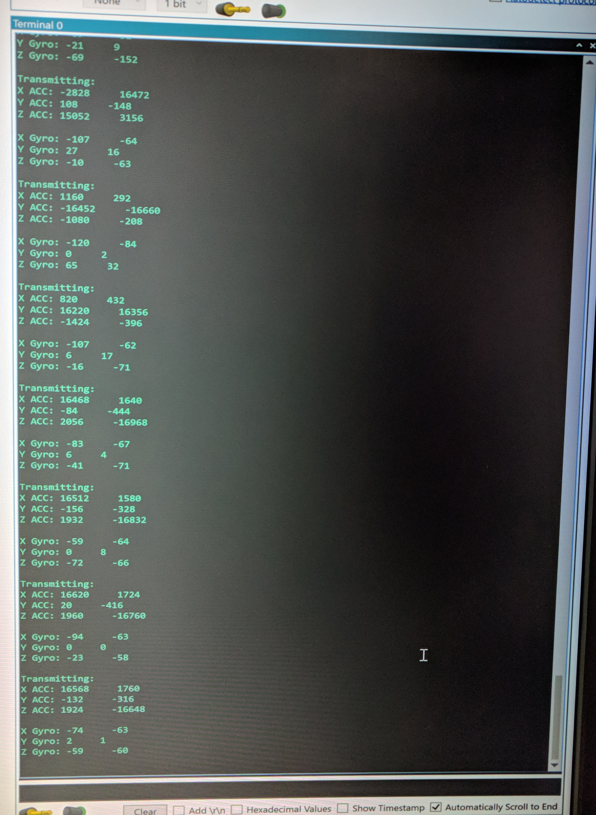

Figure 3: Two MPU6050's connected to the same AVR Accelerometer and Gyro Data. Left column is first MPU6050 data and Right column is second MPU6050 data.

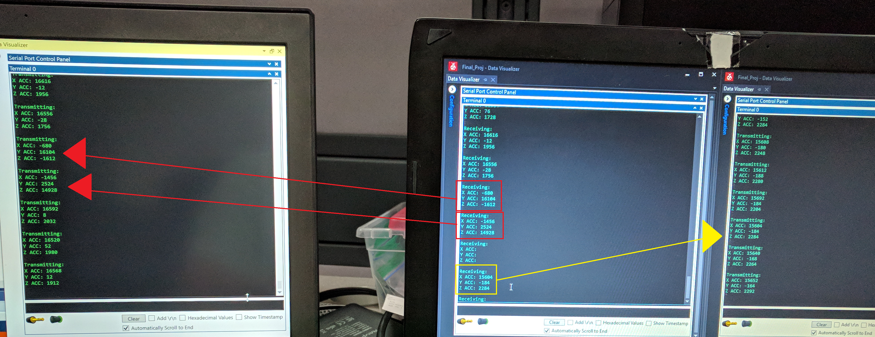

Figure 4: Three NRF Transmitter devices transmitting to one NRF receiver device and displaying values on a terminal

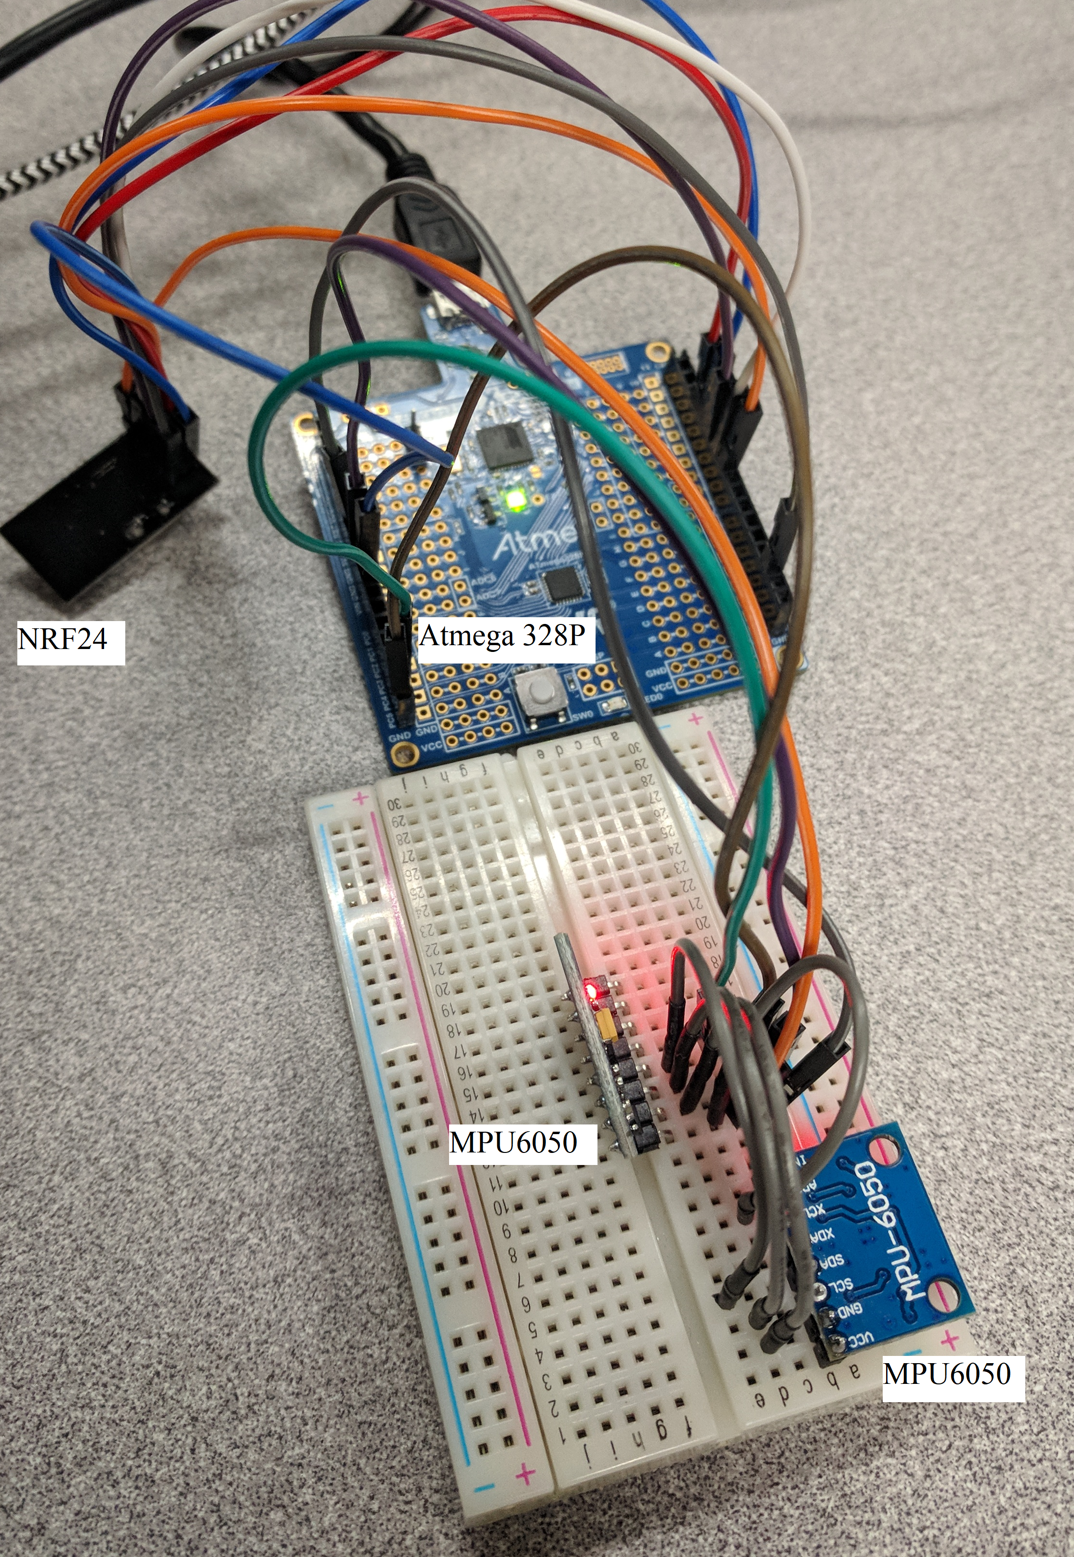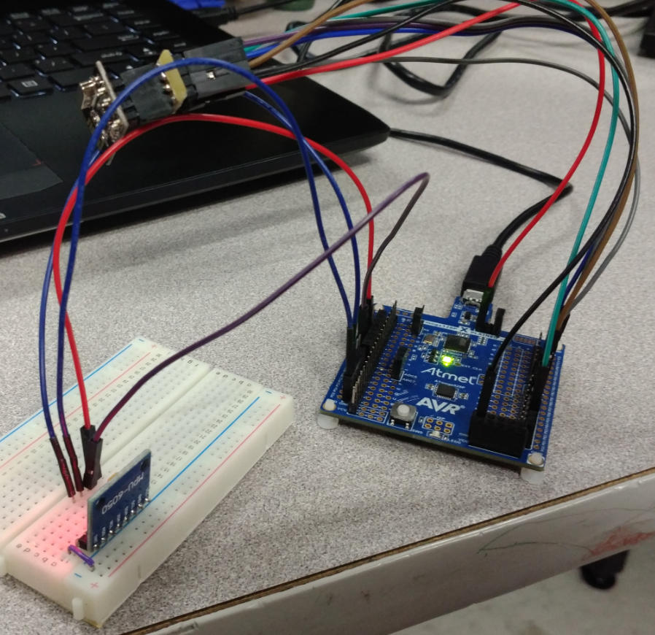

**Figure 5: Setup of the Transmitter Devices with three MPU6050's**

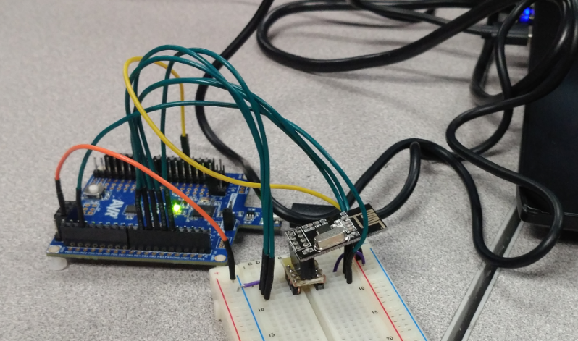

**Figure *6*: Setup of the Receiver Device**

# Links

<https://youtu.be/QE9WRfPTeTI> - Video showing two MPU6050’s printing data to terminal

<https://youtu.be/5suAdDACHiA> - Video showing third MPU6050 printing data to terminal

# Graphs

# Conclusion

The accelerometer is a very important IMU. We use them all the time in our daily lives. Our phones have them, toys, tools, and many other devices use them very actively for a variety of tasks that we don’t ever think about. Other than simple tasks our phones use them for, they are also used for high precision important tasks like monitoring an aircraft. Precision when flying is very important so the fact that they are used in all aircrafts show they have the ability to be very accurate and reliable. For being one of the most universally used and trusted devices on the market, they don’t get much credibility for how useful they are.

This is what made this final project very fun and interesting. We worked with a very commonly used device and got to know how it functions. Although frustrating at times, this was a really good project to learn about an important technology that we won’t see going away anytime soon.

REFERENCE:

Atmega328P Datasheet:

<http://ww1.microchip.com/downloads/en/DeviceDoc/Atmel-42735-8-bit-AVR-Microcontroller-ATmega328-328P_Datasheet.pdf>

AVR to NRF:

<https://docs.google.com/a/unlv.nevada.edu/viewer?a=v&pid=sites&srcid=dW5sdi5lZHV8dW5sdmNwZTMwMXMxOHxneDoxMjYwN2EyOWFkMjJiYjBi>

MPU6050 Datasheet:

<https://www.invensense.com/wp-content/uploads/2015/02/MPU-6000-Register-Map1.pdf>

MPU/I2C Sample Code:

<https://github.com/ctraabe/UTGimbal>

<https://github.com/YifanJiangPolyU/MPU6050>

1.